OK, here goes! I can’t pretend its easy… print this & study it!

A flat file system v relational database

First of all.. what are they?
A flat file system can be imagined as a spreadsheet. It contains columns. Each column will hold one item of data like this:
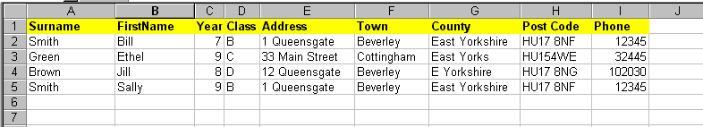
Now this could also be created in a table in Access too…
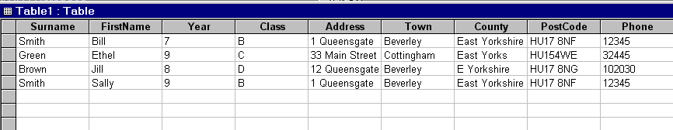
It’s the same thing. Just one table... one big collection of fields.

Look closely and you start to see some problems:
(1) We keep repeating the same entries… we keep repeating the year, class, the address, phone number for some students. This is called REDUNDANCY – it means we are repeating some data and it is redundant as we have already entered it elsewhere. A RELATIONAL DATABASE avoids this as you will see a little later.

(2) We have some inaccuracies… East Yorkshire has been entered in different ways. We could not simply create a query to find all students living in “East Yorkshire” as it would miss those in “East Yorks” and “E Yorkshire”. No CONSISTENCY. The same is true for the post code… Ethel Green has had her post code entered incorrectly (no space between the two parts.

(3) What would happen when Sally Smith turns up with a letter to say she has moved to 45 Little Lane, Little Village, East Yorkshire, phone 01445 234233? If the secretary is equipped with a crystal ball she may see that Sally has a brother Bill who will also have moved. But that means we have to change the data more than once. It would be better if the address appeared just once and both Sally and Bill were attached to it in some way. This is where relational databases come in. They avoid this unnecessary duplication and repeated changes to the same data.

The same problem as a RELATIONAL DATABASE:
We would create a different table for each type of data. One for student, one for the list of valid years, one for a list of valid classes and one for the addresses. We would set-up a RELATIONSHIP between them to show how they connect together and relate to each other like this:
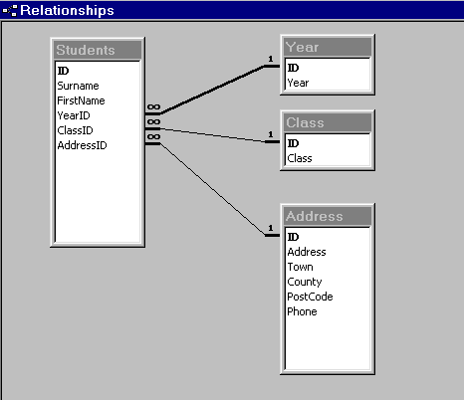
This shows us that the STUDENT table has a primary key field called ID. Every table needs a unique field to identify the record. We tend to use numbers in this field. You will see we have fields called YearID, ClassID and AddressID in the STUDENT table. These fields will hold a number. The number will be the ID in the associated table. Those funny number 8s that have fallen over mean “many”. The lines are showing what is known as “many to 1” relationships. This means that there are many students that can be in a year. There are many students that can belong to a class. There can be many students that live at the same address (eg the Smiths in these examples).

Here are the contents of YEAR and CLASS tables to look at:
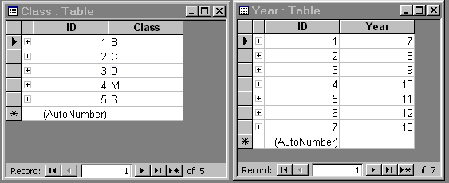
If a student was in year 9, then the yearID field in the STUDENT table will hold the number 3. If a student is in class M, then the classID field in the STUDENT table will hold the number 4. Remember these numbers in yearID & classID simply identify the record in the tables that the student is connected/related to!

And now the address table would look something like this:

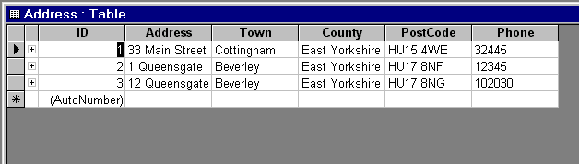

You can set-up default values and validation that eliminates errors in the PostCode field. (You use something called an input mask that lets you say exactly how many characters are to be typed in, where the spaces go and if they characters should be letters or numbers)

The STUDENT table would look like this:
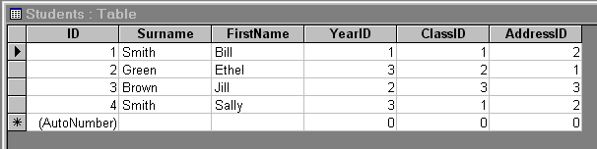

You will see the YearID and ClassID hold the numbers of the record in the other fields as I said. You can also see the AddressID that points to the correct record in the ADDRESS table. NOTE: that the SMITHs both have the same addressed… 2. Check the ADDRESS table and record 2 is their address. Now If Sally turns up, we make one change in the ADDRESS table and this will immediately be the address for brother Bill.

Another big advantage of relational databases? Searching/queries. It is far easier to search this kind of organised structure than a flat file system. Why? Because all entries in the tables are controlled and consistent. We haven’t entered a class called Minster for one person and M for another. All are M. Very easy to search for!

Are there advantages to using a flat file system?
Yes! Its easy to set-up! They are fine to use for simple data storage – something like a list of your friends and their phone numbers and birthdays. But serious data storage needs serious planning and the use of a relational database structure.

Hope this helps… if you have further questions about this or other topics DO Email me again.

